**Lab-02**

Q1. Find the names of all branches in the “loan” relation.

Query:

Select branch_name from loan;

Output:

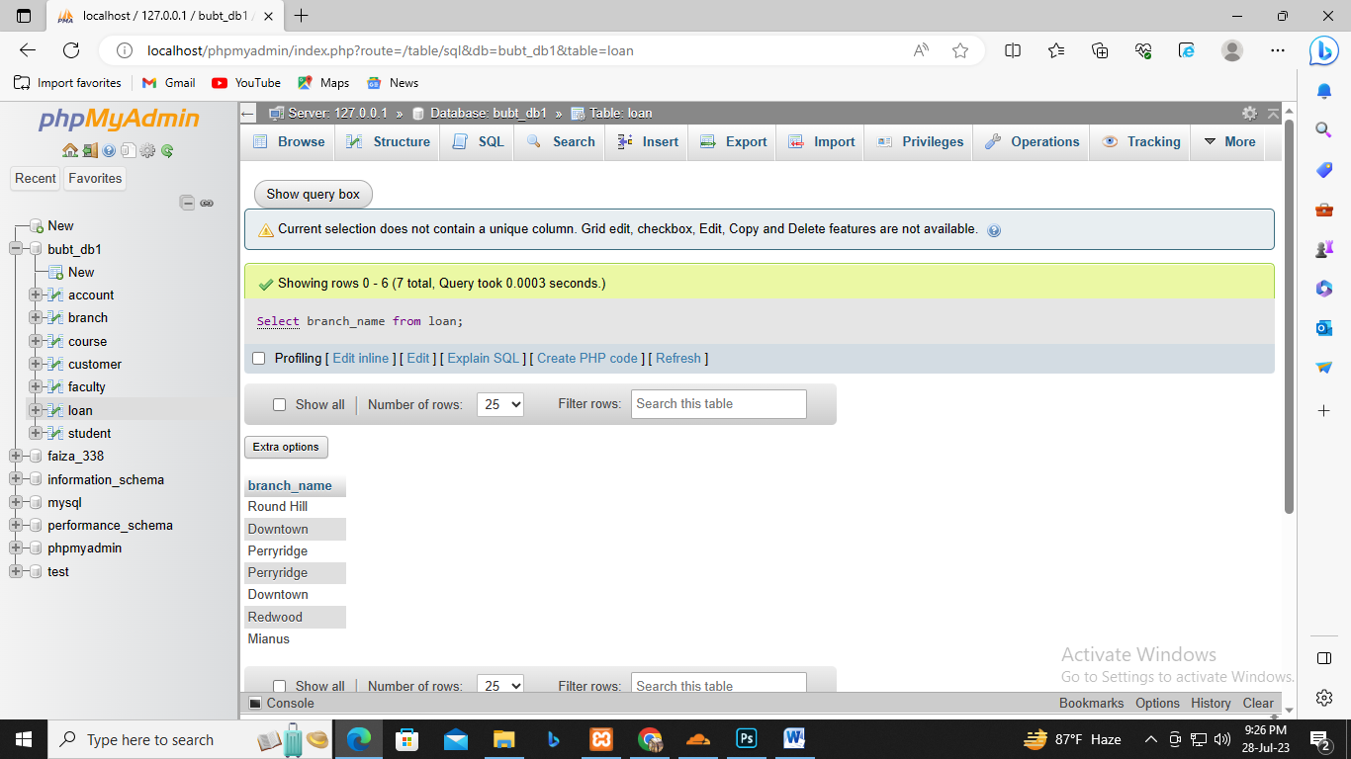

Q2. Find all loan numbers for loans made at the “Perryridge” branch with loan amounts greater

than 300.

Query:

select loan_number from loan WHERE branch_name="Perryridge" AND amount>300;

output:

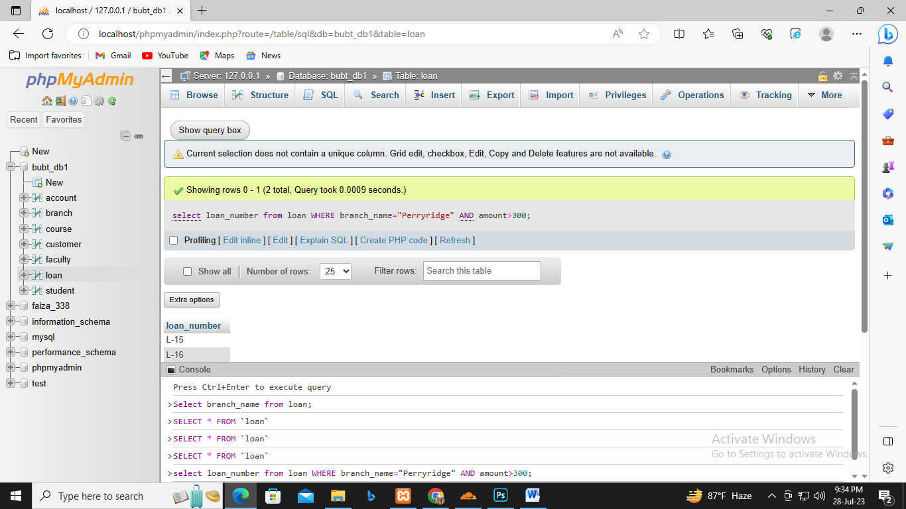

Q3. Find all the loan numbers of the customers who has loan either “Perryridge” branch or

“Downtown” branch.

Query:

select loan_number from loan WHERE branch_name="Perryridge" OR branch_name="Downtown";

Output:

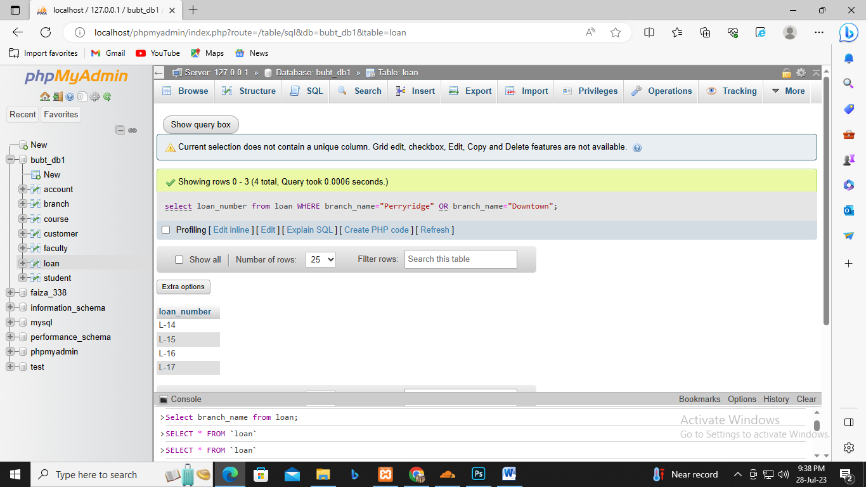

Q4. Find all the loan numbers of the customers who has loan either “Perryridge” branch or

“Downtown” branch or “Mianus” branch.

Query:

select loan_number from loan WHERE branch_name IN("Perryridge","Downtown","Mianus");

Output:

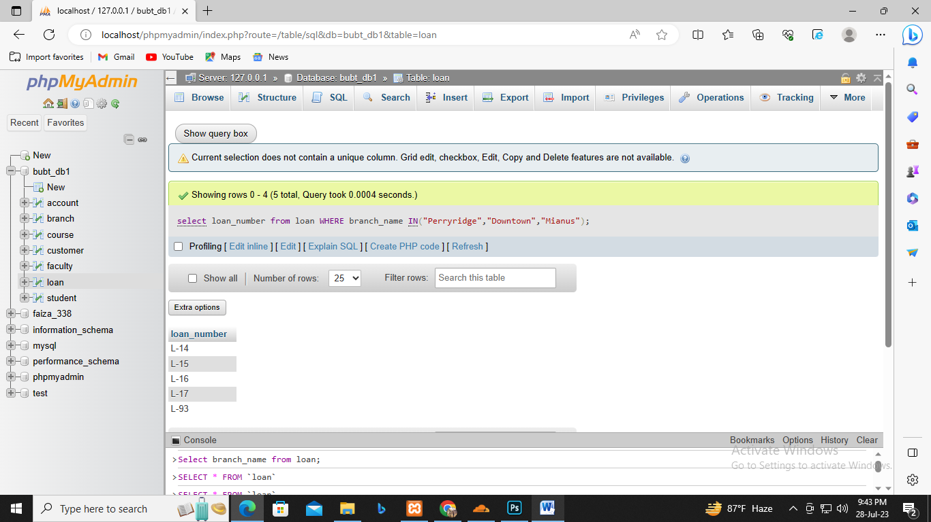

Q5. Find the names of all customers who are not from “Stamford” or “Princeton” or ”Harrison”

City.

Query:

select customer_name from customer WHERE customer_city NOT IN("Princeton");

Output:

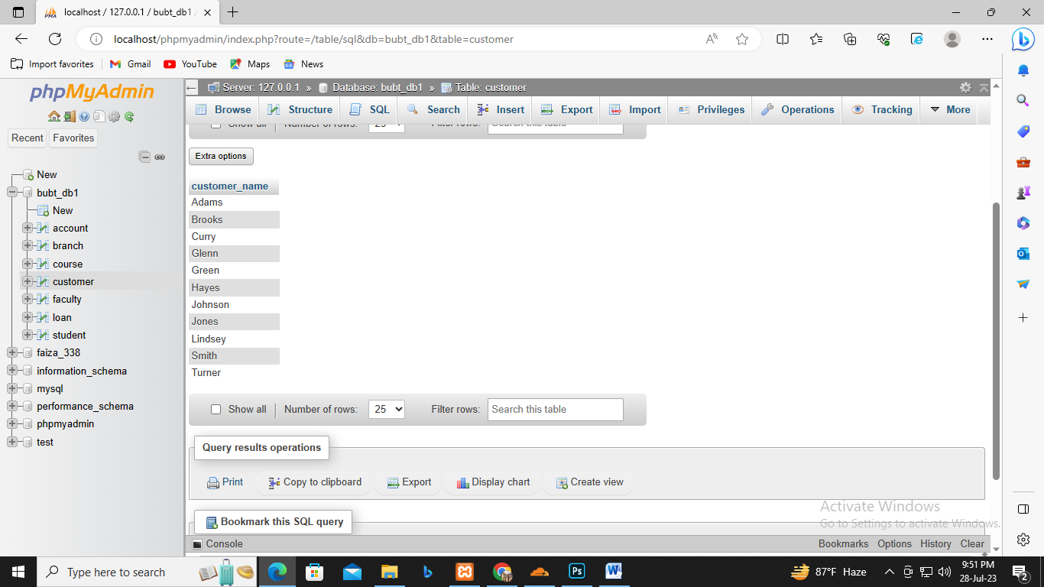

Q6. Find the largest , minimum and average account balance in the “Account” relation.

Query:

Select Max(balance) "Maximum", Min(balance) "Minimum", AVG(balance) "Average" from account;

Output:

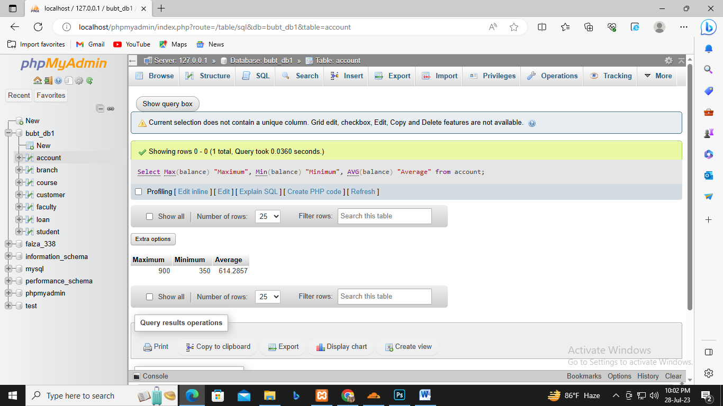

Q7. Find the total number of customer from “Customer” relation.

Query:

Select Count(customer_name) "Total number of customers:" from customer;

Output:

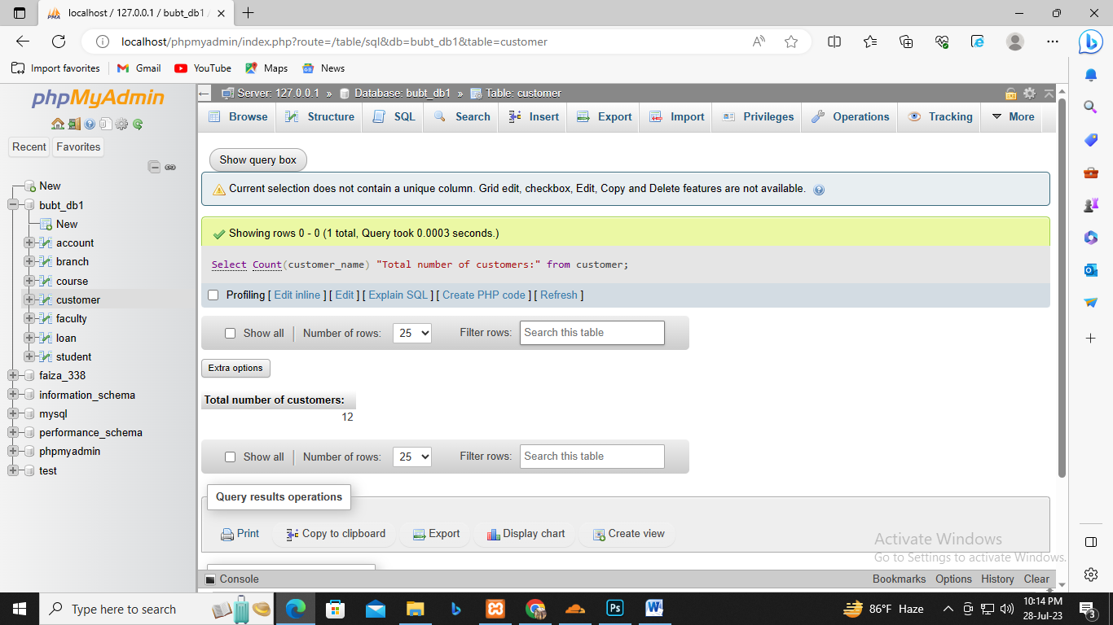

Q8. Find the loan number of those loans with loan amounts between 400 and 800.

Query:

select loan_number from loan WHERE amount BETWEEN 400 AND 800;

Output:

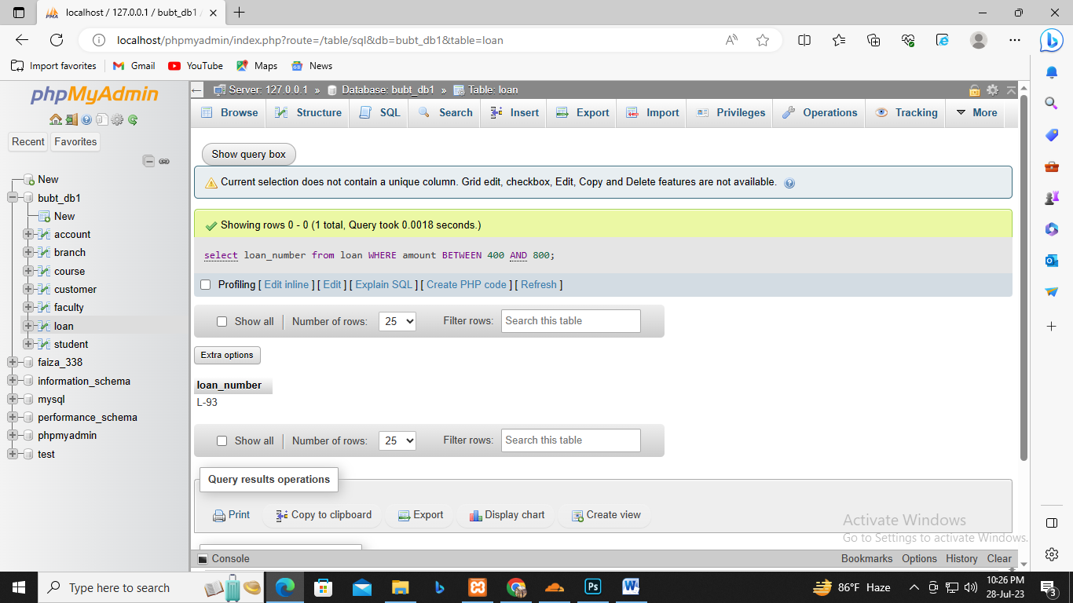

Q9. Find the names of all customers whose name start with ”G”.

Query:

Select customer_name from customer where customer_name like 'G%';

Output:

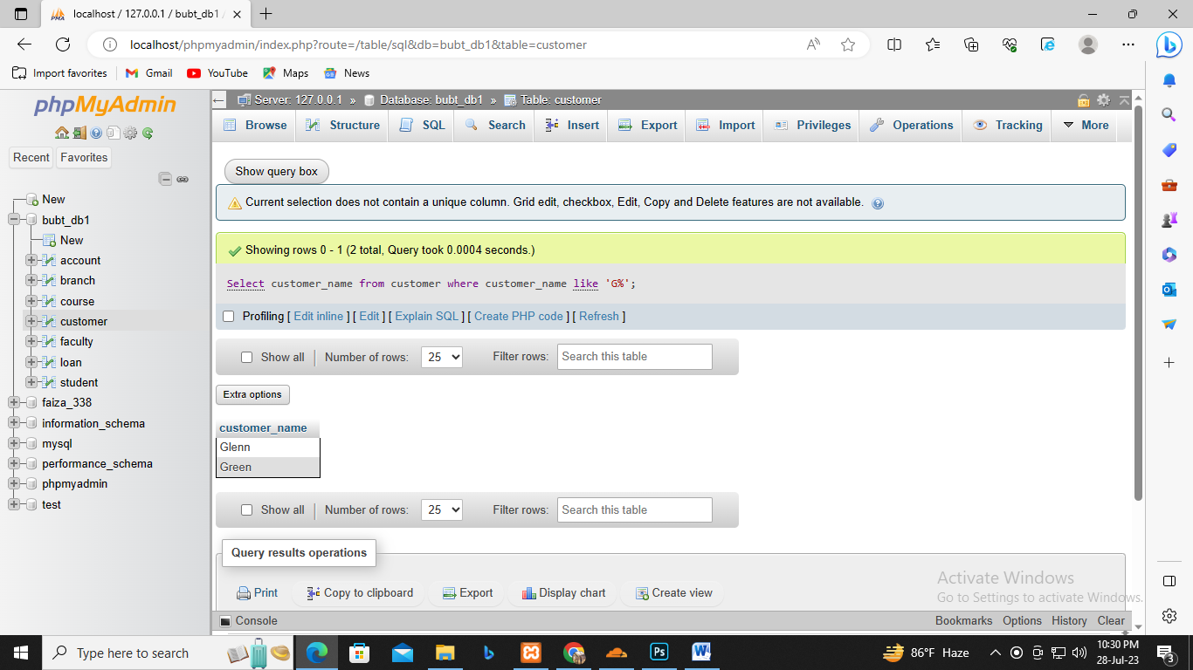

Q10. Find the names of all customers whose name ends with ”s”.

Query:

Select customer_name from customer where customer_name like '%s';

Output:

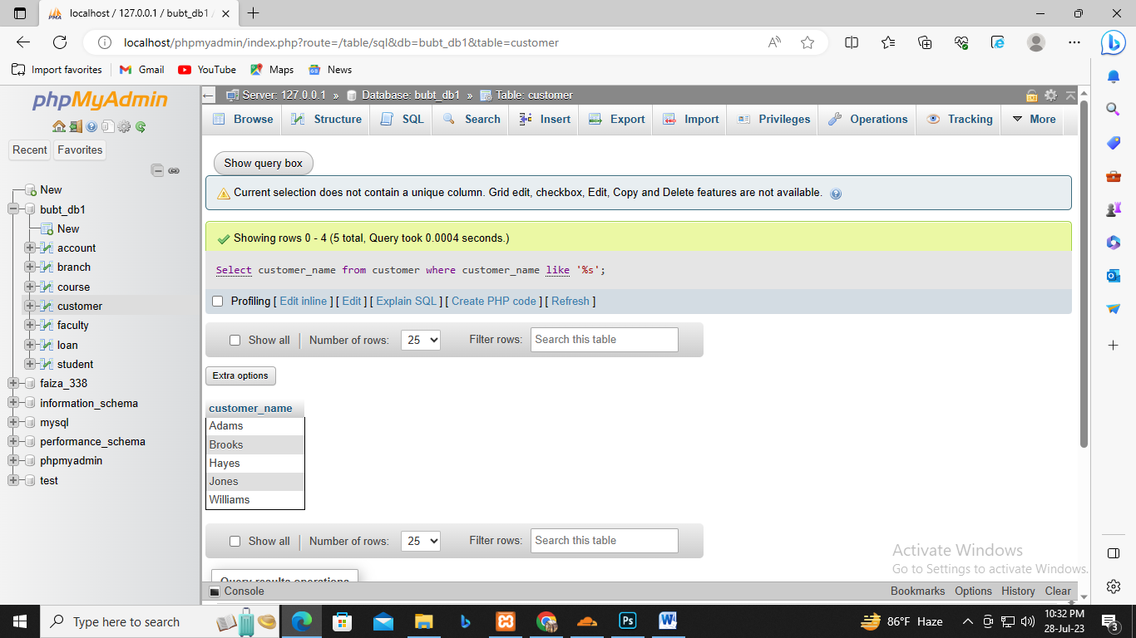

Q11. Find the names of all customers whose name has a “o” in 2 nd position.

Query:

select customer_name from customer where customer_name like '_o%';

Output:

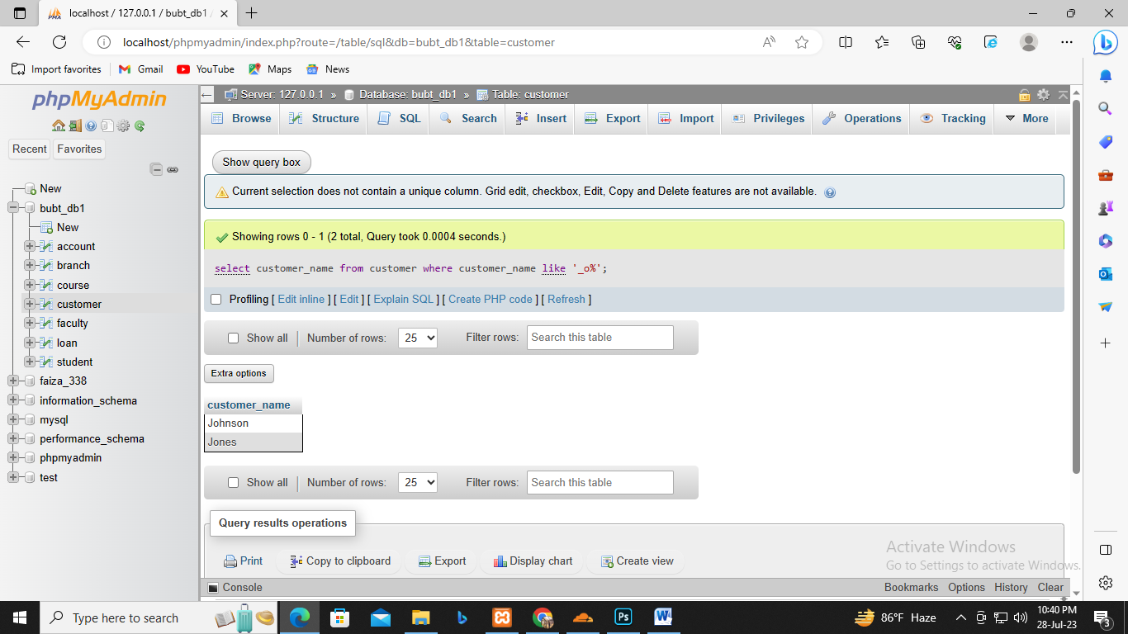

Q12. Find the names of all customers whose name has a “o” in any position except 1 st and last

letter.

Query:

Select customer_name from customer where customer_name like '%o%';

Output:

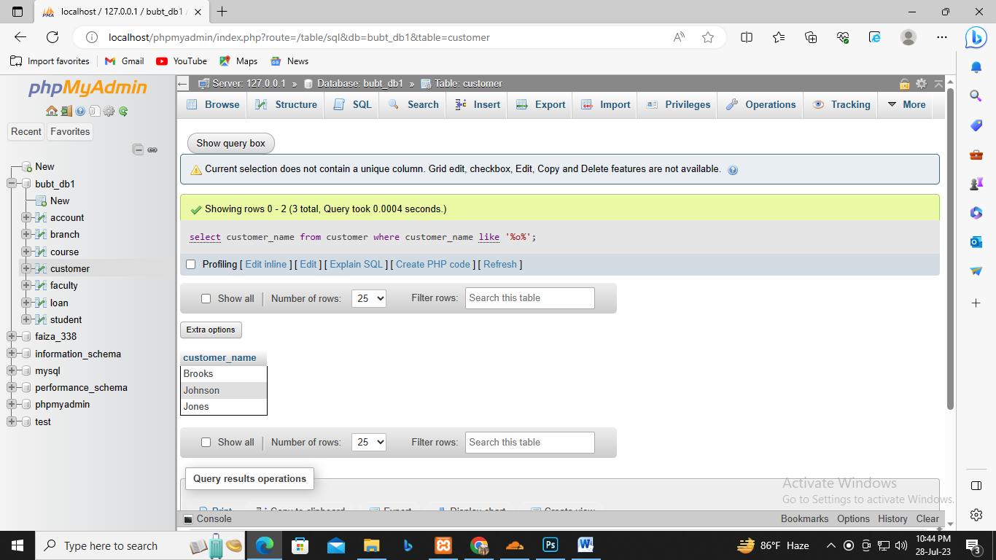

Q13. Find the length of the name of all customers from “Customer” relation.

Query:

Select customer_name, Length(customer_name) "Length" from customer;

Output:

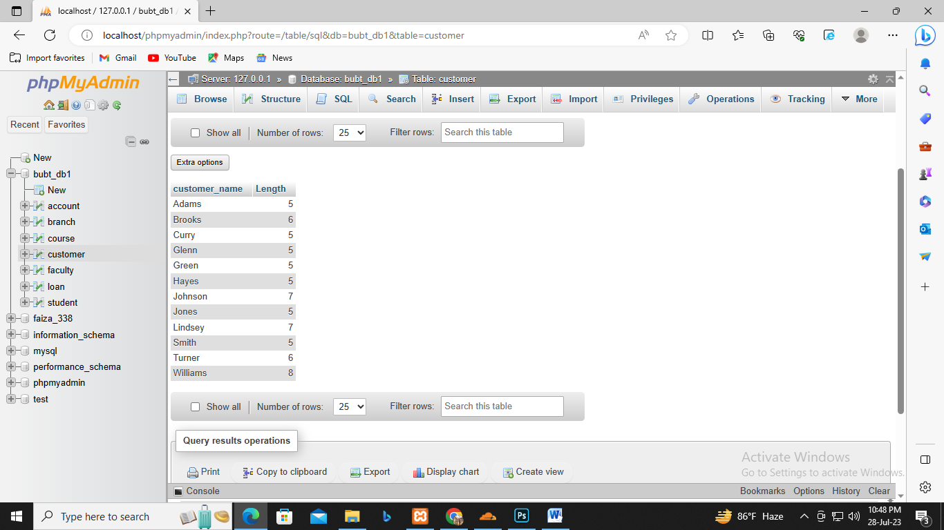

Q14. Find 1st three characters of each customer name from “customer” relation.

Query:

Select customer_name, SUBSTR(customer_name,1,3) from customer;

Output:

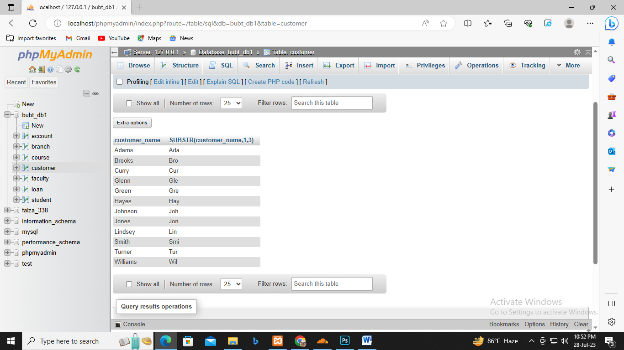

**Lab-03**

Q1. Find the number of customers from all cities in

“Customer” relation.

[SELECT](http://localhost/phpmyadmin/url.php?url=https://dev.mysql.com/doc/refman/8.0/en/select.html) Customer_City,[COUNT](http://localhost/phpmyadmin/url.php?url=https://dev.mysql.com/doc/refman/8.0/en/aggregate-functions.html%23function_count)(Customer_Name)"Total No of Customers" FROM customer GROUP BY Customer_City;

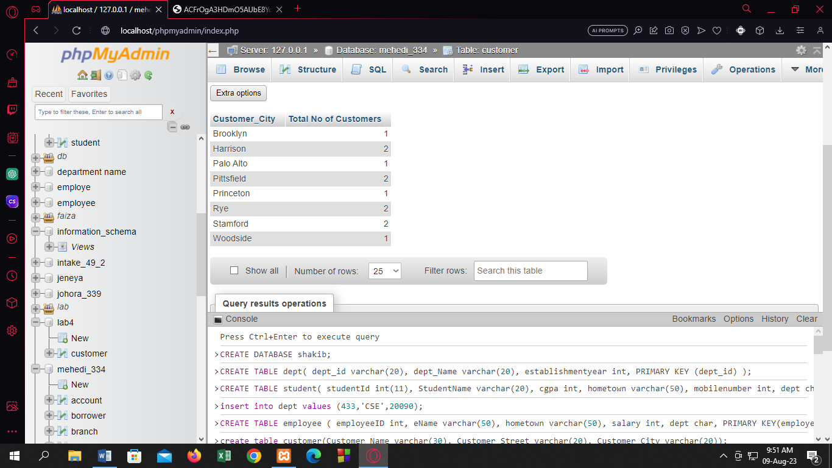

Q2.Find the total no. of loans from “Loan” relation from

each branch.

[SELECT](http://localhost/phpmyadmin/url.php?url=https://dev.mysql.com/doc/refman/8.0/en/select.html) Branch_name,[COUNT](http://localhost/phpmyadmin/url.php?url=https://dev.mysql.com/doc/refman/8.0/en/aggregate-functions.html%23function_count)(Loan_number)"No of Loans" FROM loan GROUP BY Branch_name;

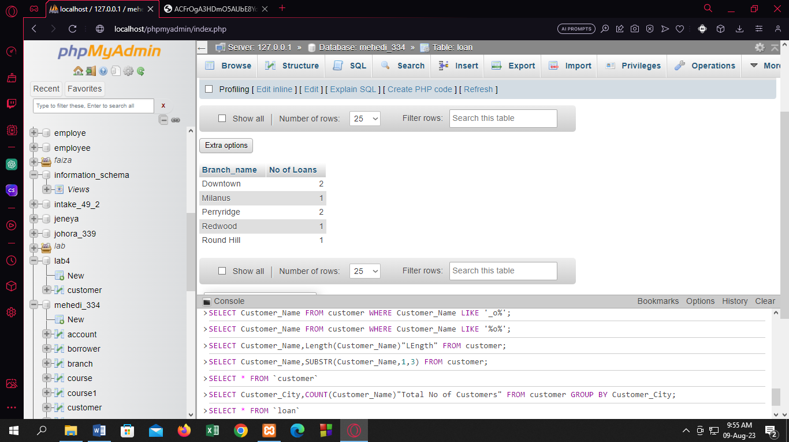

Q3. Find the total amount of loan from “Loan” relation of

each branch which amount is greater than 1200.

[SELECT](http://localhost/phpmyadmin/url.php?url=https://dev.mysql.com/doc/refman/8.0/en/select.html) Branch_name,[SUM](http://localhost/phpmyadmin/url.php?url=https://dev.mysql.com/doc/refman/8.0/en/aggregate-functions.html%23function_sum)(Amount) FROM loan GROUP BY Branch_name HAVING [SUM](http://localhost/phpmyadmin/url.php?url=https://dev.mysql.com/doc/refman/8.0/en/aggregate-functions.html%23function_sum)(Amount)>1200;

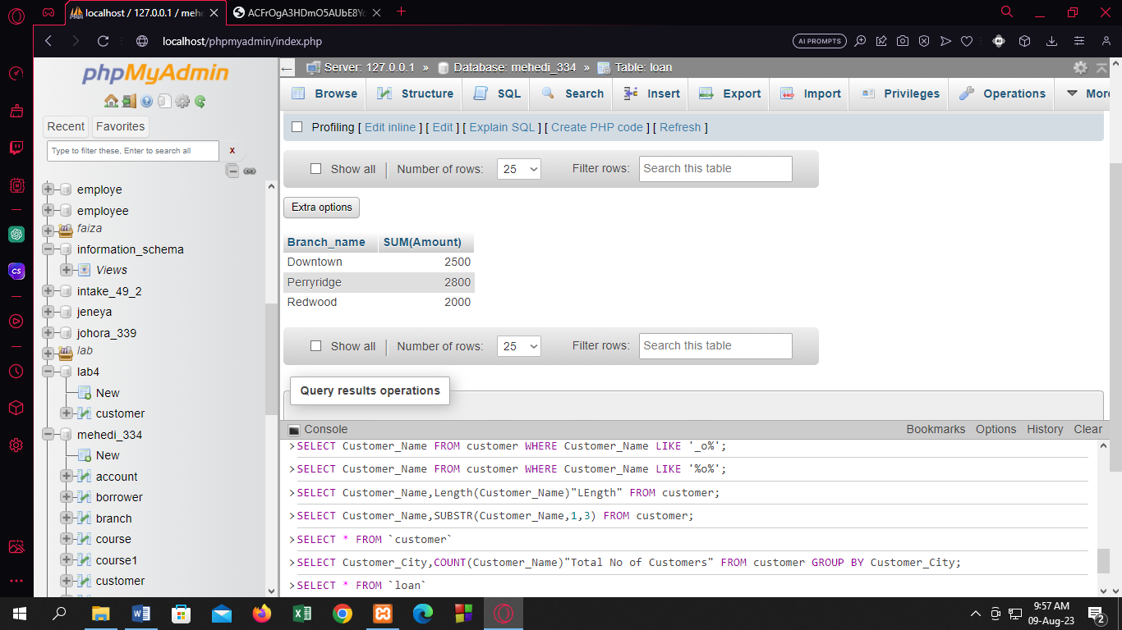

Q4. Find the average amount from each branch of “loan”

relation.

[SELECT](http://localhost/phpmyadmin/url.php?url=https://dev.mysql.com/doc/refman/8.0/en/select.html) Branch_name,[AVG](http://localhost/phpmyadmin/url.php?url=https://dev.mysql.com/doc/refman/8.0/en/aggregate-functions.html%23function_avg)(Amount) "Average Amount" FROM loan GROUP BY Branch_name;

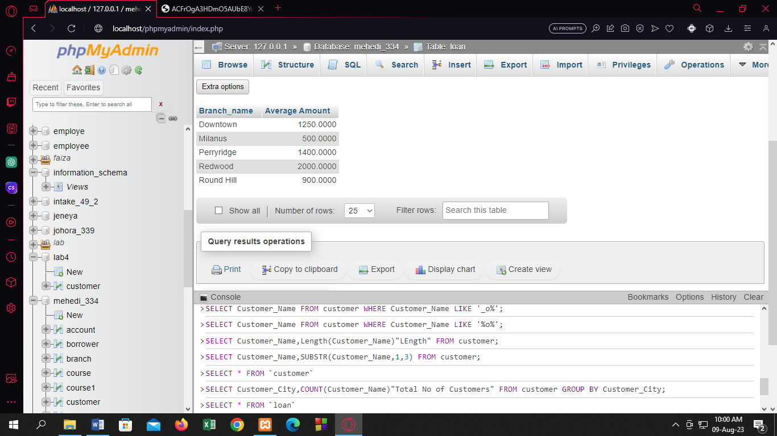

Q5. Find the total amount of each branch from “loan”

relation.

[SELECT](http://localhost/phpmyadmin/url.php?url=https://dev.mysql.com/doc/refman/8.0/en/select.html) Branch_name,[SUM](http://localhost/phpmyadmin/url.php?url=https://dev.mysql.com/doc/refman/8.0/en/aggregate-functions.html%23function_sum)(Amount) "Sum Amount" FROM loan GROUP BY Branch_name;

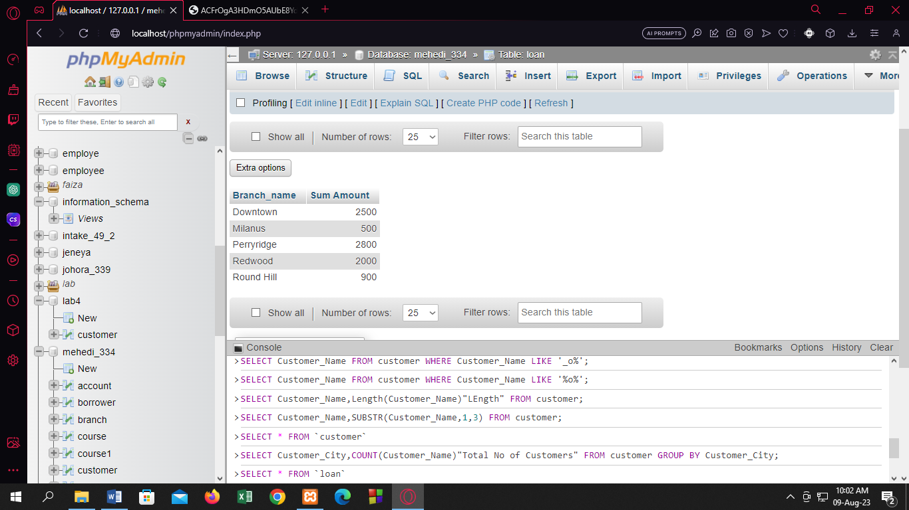

Q6. Find the total number of tuples for loan and

account relation.

[SELECT](http://localhost/phpmyadmin/url.php?url=https://dev.mysql.com/doc/refman/8.0/en/select.html) [COUNT](http://localhost/phpmyadmin/url.php?url=https://dev.mysql.com/doc/refman/8.0/en/aggregate-functions.html%23function_count)(*) FROM loan;

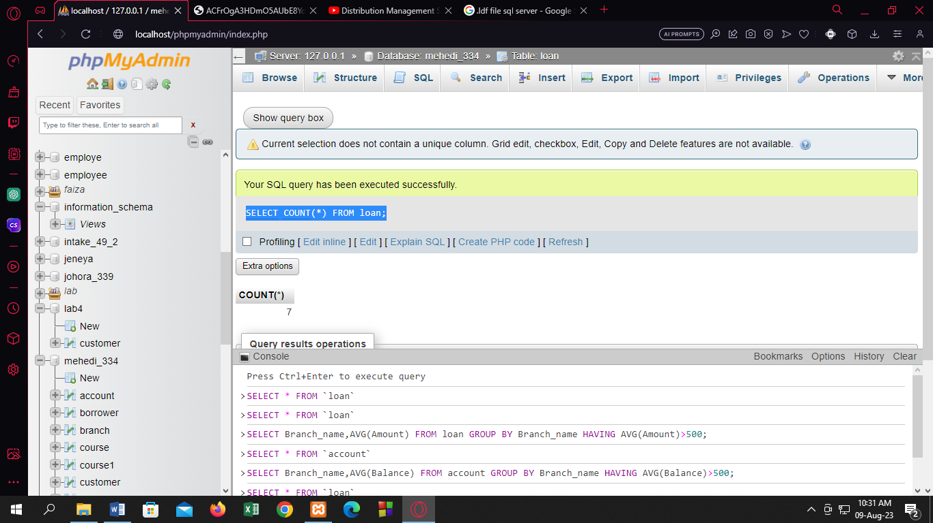

[SELECT](http://localhost/phpmyadmin/url.php?url=https://dev.mysql.com/doc/refman/8.0/en/select.html) [COUNT](http://localhost/phpmyadmin/url.php?url=https://dev.mysql.com/doc/refman/8.0/en/aggregate-functions.html%23function_count)(*) FROM account;

Q7. Find the average account balance of each branch whose

average account balance is greater than 500.

[SELECT](http://localhost/phpmyadmin/url.php?url=https://dev.mysql.com/doc/refman/8.0/en/select.html) Branch_name,[AVG](http://localhost/phpmyadmin/url.php?url=https://dev.mysql.com/doc/refman/8.0/en/aggregate-functions.html%23function_avg)(Amount) FROM loan GROUP BY Branch_name HAVING [AVG](http://localhost/phpmyadmin/url.php?url=https://dev.mysql.com/doc/refman/8.0/en/aggregate-functions.html%23function_avg)(Amount)>500;

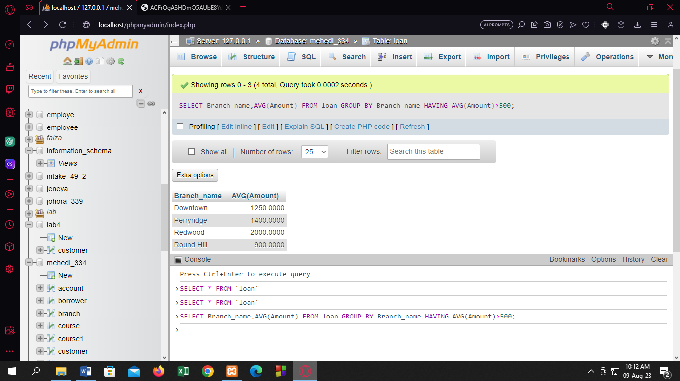

[SELECT](http://localhost/phpmyadmin/url.php?url=https://dev.mysql.com/doc/refman/8.0/en/select.html) Branch_name,[AVG](http://localhost/phpmyadmin/url.php?url=https://dev.mysql.com/doc/refman/8.0/en/aggregate-functions.html%23function_avg)(Balance) FROM account GROUP BY Branch_name HAVING [AVG](http://localhost/phpmyadmin/url.php?url=https://dev.mysql.com/doc/refman/8.0/en/aggregate-functions.html%23function_avg)(Balance)>500;

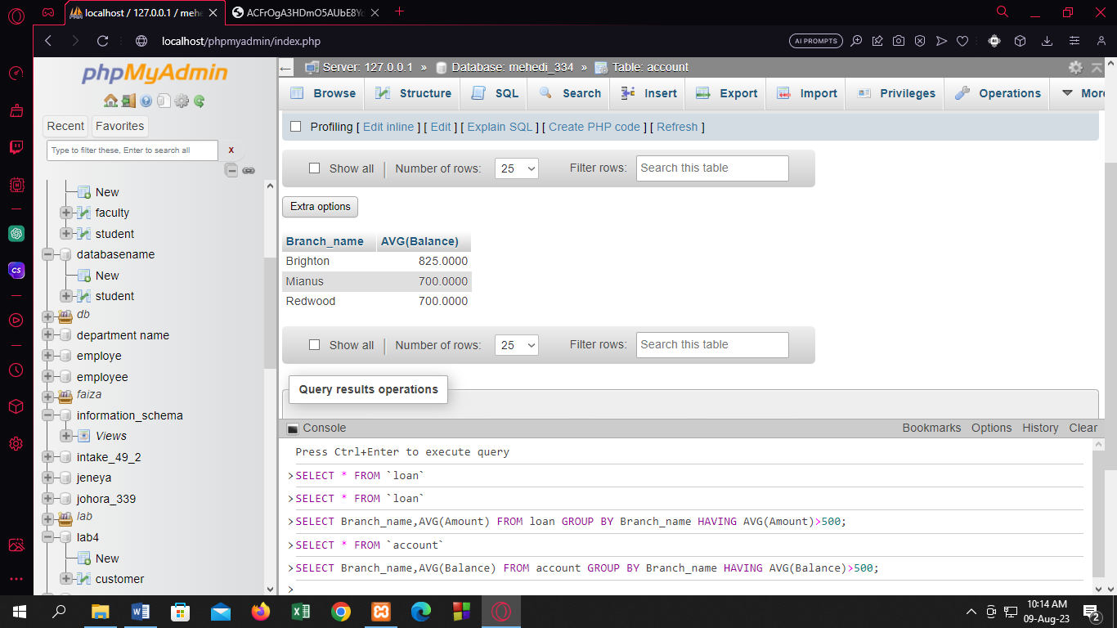

Q8. Find the name of all those customers who has either a

loan or an account or both.

[SELECT](http://localhost/phpmyadmin/url.php?url=https://dev.mysql.com/doc/refman/8.0/en/select.html) Customer_name FROM borrower UNION [SELECT](http://localhost/phpmyadmin/url.php?url=https://dev.mysql.com/doc/refman/8.0/en/select.html) Customer_Name FROM depositor;

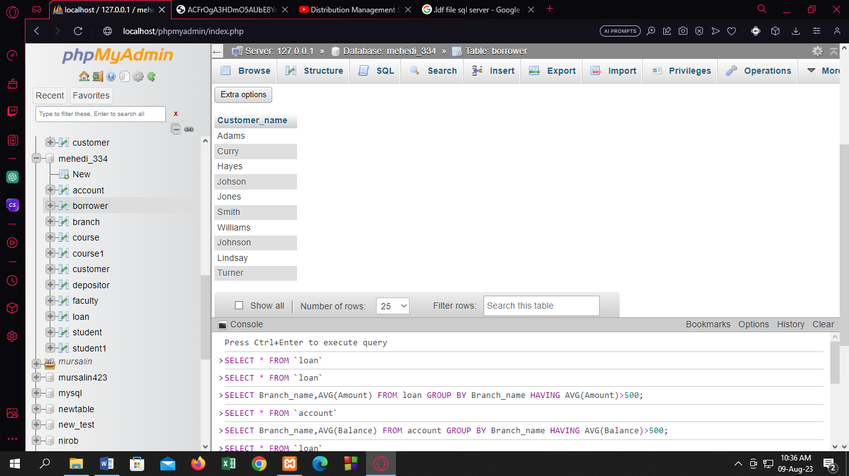

Q9. Find the name of all those customers who has both a

loan and an account.

[SELECT](http://localhost/phpmyadmin/url.php?url=https://dev.mysql.com/doc/refman/8.0/en/select.html) Customer_name FROM borrower intersect [SELECT](http://localhost/phpmyadmin/url.php?url=https://dev.mysql.com/doc/refman/8.0/en/select.html) Customer_Name FROM depositor;

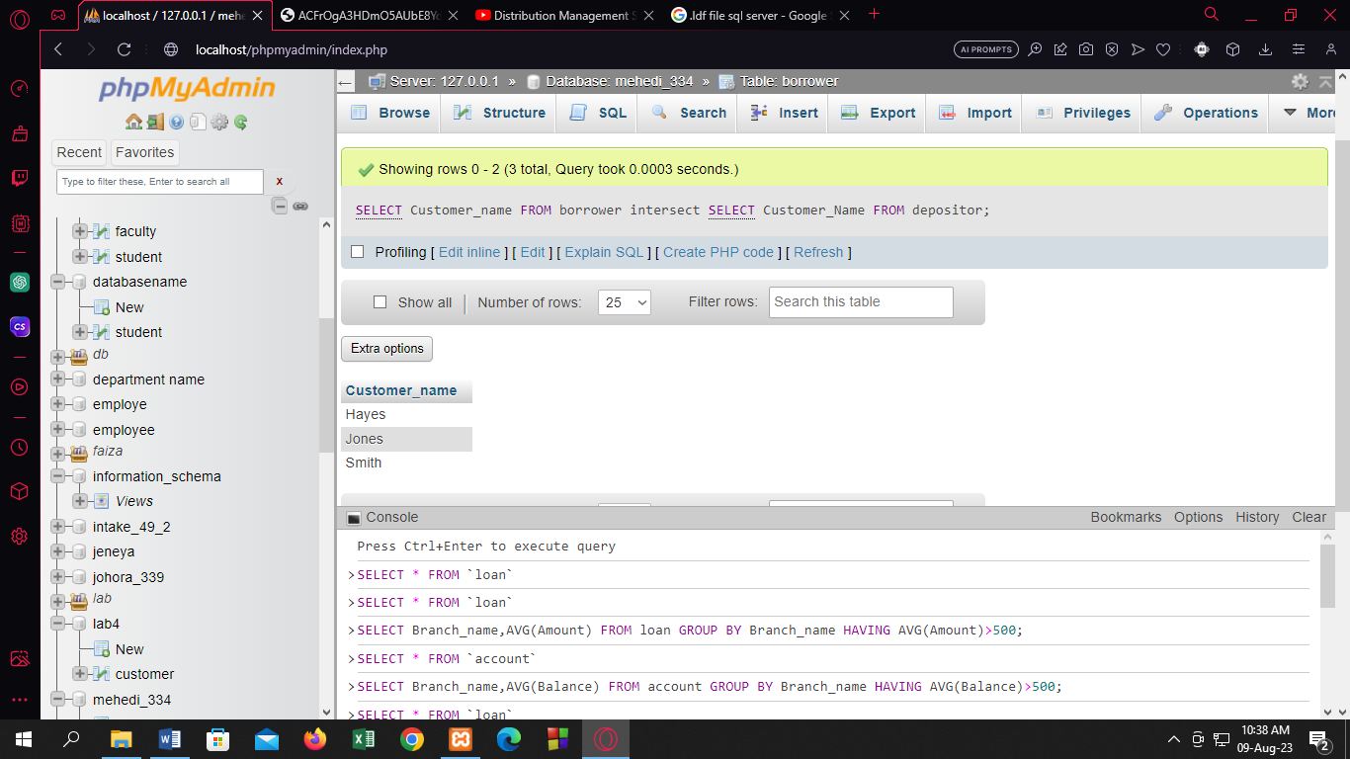

Q10. Find the name of all those customers who has only

an account but not any loan.

[SELECT](http://localhost/phpmyadmin/url.php?url=https://dev.mysql.com/doc/refman/8.0/en/select.html) Customer_name FROM depositor WHERE Customer_Name [NOT](http://localhost/phpmyadmin/url.php?url=https://dev.mysql.com/doc/refman/8.0/en/logical-operators.html%23operator_not) [IN](http://localhost/phpmyadmin/url.php?url=https://dev.mysql.com/doc/refman/8.0/en/comparison-operators.html%23function_in)( [SELECT](http://localhost/phpmyadmin/url.php?url=https://dev.mysql.com/doc/refman/8.0/en/select.html) Customer_Name FROM borrower);

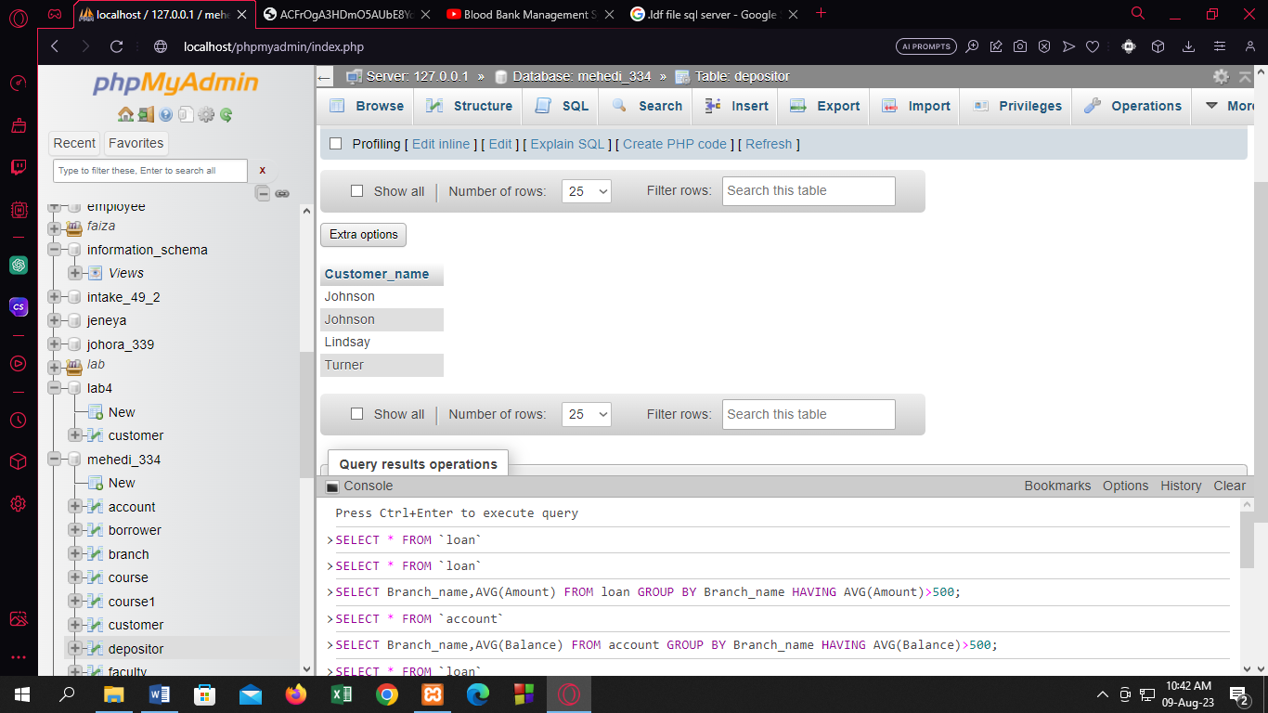

Q11: Change the column name from “branch_city” of

branch relation to “city”.

[ALTER](http://localhost/phpmyadmin/url.php?url=https://dev.mysql.com/doc/refman/8.0/en/alter-table.html) [TABLE](http://localhost/phpmyadmin/url.php?url=https://dev.mysql.com/doc/refman/8.0/en/alter-table.html) branch CHANGE COLUMN Branch_city city varchar(30);

